**LETTER OF ACCEPTANCE**

{{ TODAY }}

**Student Name:** {{ STUDENT_LASTNAME }}, {{ STUDENT_FIRSTNAME }}

**Date of Birth:** {{ DOB }}

**Class Start Date:** {{ ENROLL_DATE }}

**Expected Completion Date:** {{ EXPECTED_GRAD }}

Dear {{ STUDENT_FIRSTNAME }},

Congratulations! We are pleased to inform you that you have been admitted to Emerald Valley Academy as a full-time student for the academic year starting 2024-July-01.

**Program Type:**

**Grade 9-12 High School Credit Courses and University Preparation Program**

Emerald Valley Academy is registered with the Ontario Ministry of Education (BSID: 887678), and you will be enrolled in credits leading to an Ontario Secondary School Diploma.

The tuition fee includes credit courses per year, also the insurance, registration, activities and materials, etc. If you would like further information about program, please contact our school administration officer: [admissions@evaschool.ca](mailto:admissions@evaschool.ca).

I wish you every success and, once again, welcome you to our school.

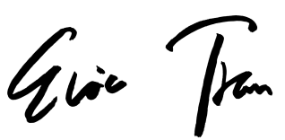Sincerely,

Eric Tran

Principal

Emerald Valley Academy